**SQL Exercise 9**

1. Display the minimum Status in the Supplier table.

select min(status) from supplier;

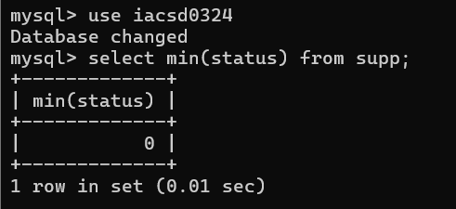

1. Display the maximum Weight in the Parts table.

select max(weight) from parts;

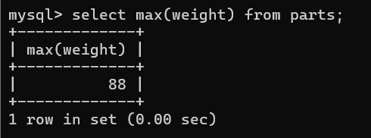

1. Display the average Weight of the Parts.

select avg(weight) from parts;

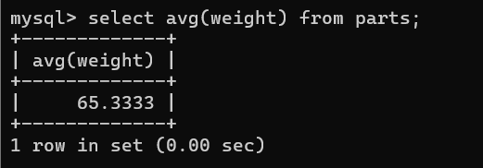

1. Display the total Quantity sold for part ‘P1’.

select qty from spj where pid=101;

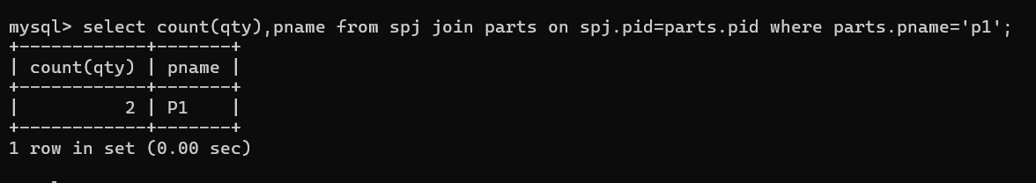

1. Display the total Quantity sold for each part.

select pid,count(qty) from spj group by pid;

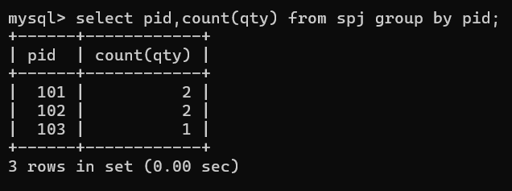

1. Display the average Quantity sold for each part.

select pid,avg(qty) from spj group by pid;

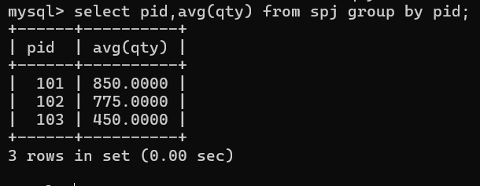

1. Display the maximum Quantity sold for each part, provided the maximum Quantity is greater than 800.

select pid,max(qty) from spj group by pid having max(qty)>800;

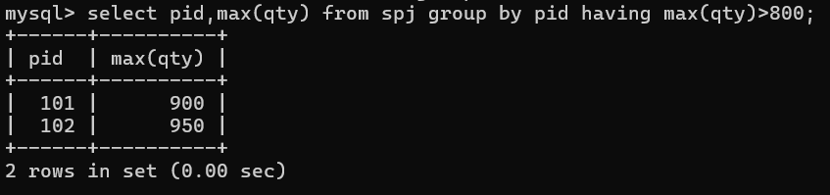

1. Display the Status and the count of Suppliers with that Status.

select status, count(sid) from supplier group by status;

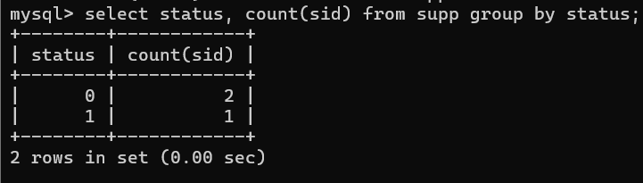

1. Display the count of Projects going on in different cities.

select city,count(jid) no_of_projects from projects group by city;

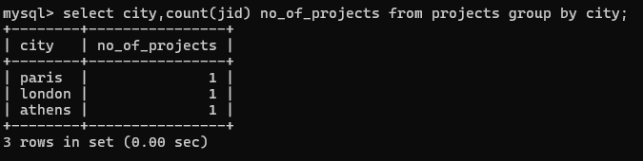

1. What is the difference between COUNT(Status) and COUNT(*) ?

select count(*),count(Status) from supplier;

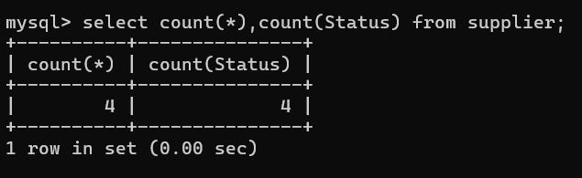

1. Display the Status and the Count of Suppliers with that Status in the following format as shown below:-

**Status Count**

Ten 1

Twenty 2

Thirty 3

select status, count(status) from supplier group by status;

